# Name: Syed Mustafa

# Registration Number: SP23-BSE-015

Use Case 1: Submit Proposal

**Use Case Name:** Submit Proposal

**Actor:** Student

**Goal in Context:** The student wants to submit a proposal document for the assigned project.

**Preconditions:**

The student must be logged into the system.

The student must be part of a group.

The project must be assigned.

**Postconditions:**

* Proposal is submitted and saved in the system.
* Submission date is recorded.

**Main Success Scenario (Basic Flow):**

* Student logs into the system.
* Navigates to the proposal submission section.
* Uploads the proposal document.
* Enters any required metadata (e.g., title, description).
* Submits the proposal.
* System stores the proposal and confirms submission.
* System logs the date and time of submission.

**Extensions (Alternative Flows):**

1. If the file format is invalid, system shows an error message.
2. If required fields are missing, system prevents submission and displays a prompt.

**Includes**

**Date of submission**

**Special Requirements**

The uploaded document must be in PDF or DOCX format.

Maximum file size allowed: 10MB.

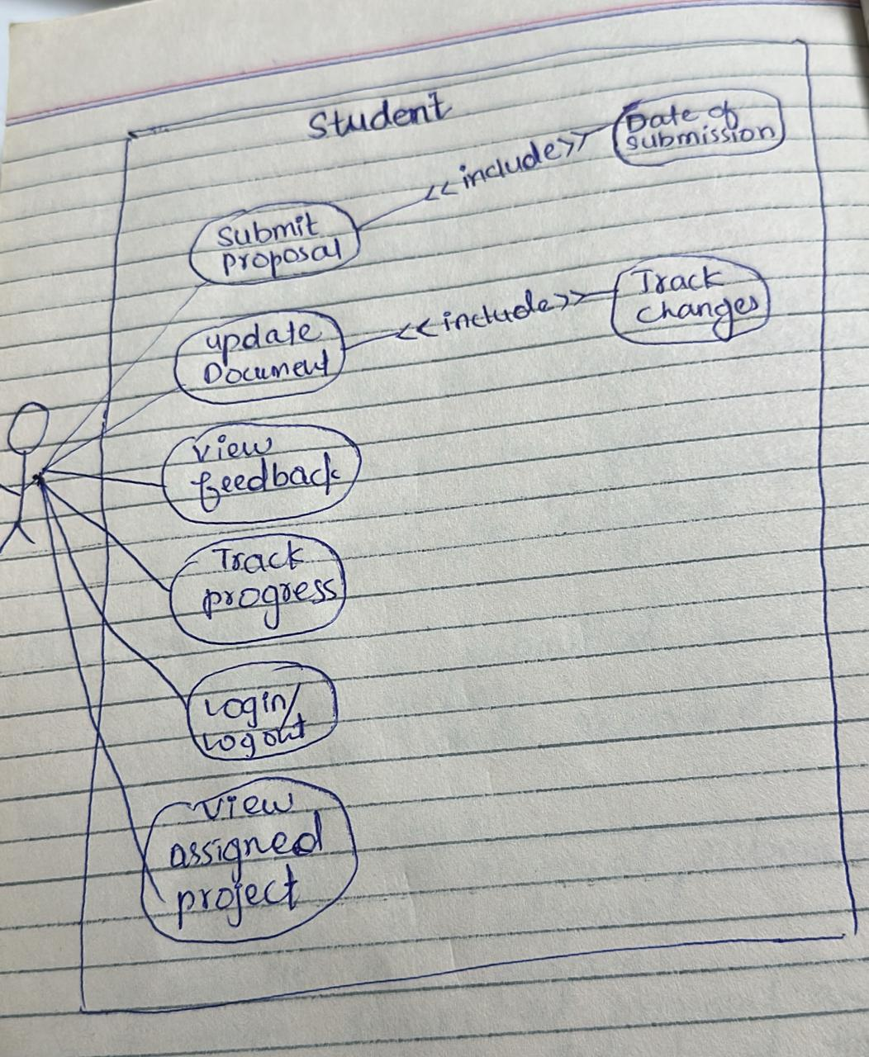**USECASE DIAGRAM _**

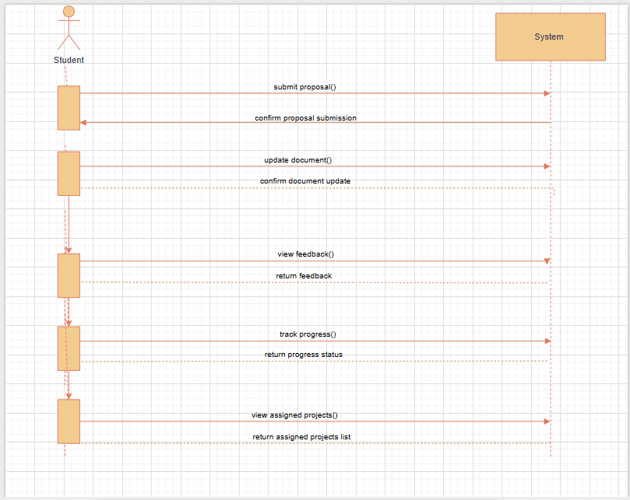**SYSTEM SEQUENCE DIAGRAM FOR STUDENT_**